Nama: Muhammad Alfarizy

NIM : 2311532010

**Pseudocode**

for i = 1 to 1 do

output("#================#")

end for

for b = 1 to 4 do

output("|")

for j = 1 to (b * -2 + 8) do

output(" ")

end for

output("<>")

for T = 1 to (b * 4 - 4) do

output(".")

end for

output("<>")

for j = 1 to (b * -2 + 8) do

output(" ")

end for

output("|")

end for

for b = 1 to 4 do

output("|")

for j = 1 to (b * 2 - 2) do

output(" ")

end for

output("<>")

for t = 1 to (b * -4 + 16) do

output(".")

end for

output("<>")

for j = 1 to (b * 2 - 2) do

output(" ")

end for

output("|")

end for

for i = 1 to 1 do

output("#================#")

end for

end procedure

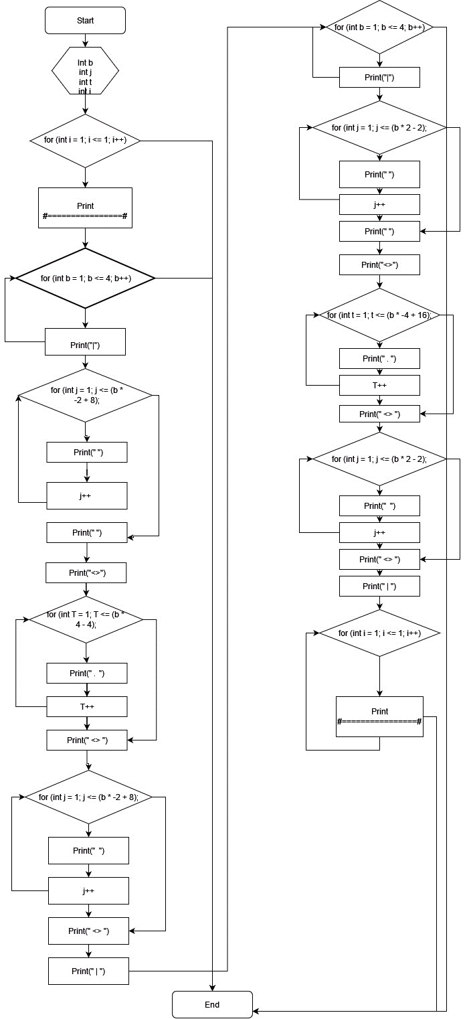**Flowchart**